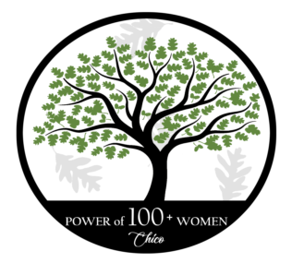
Non-Profit Fact Sheet & Application
Power of 100+ Women – Chico https://cpw100.squarespace.com/

Scan this form and proof of your non-profit status to:
chicopower100women@gmail.com

Organization Name:

Address:

Contact Name:

Contact Email:

Contact Phone:

Website:

Organization Mission Statement:

Date Established:

How would donated funds be used?

501c3 Number:

- I agree not to use, give or sell the contact information of your members for additional solicitation by us or other organizations.
- I agree to provide thank you/tax receipts to contributing members.
- I agree to provide Power of 100+ Women – Chico with our logo for advertising purposes.
- I understand that funds are to be used for a specific project and not every day operating expenses.
- I agree to attend, or send a representative, to two meetings if selected.

__________________________________________________ Date:
Signature and Title

